Introduction to Salesforce Chatter

While we’ve had Salesforce Chatter available for almost a year now, we haven’t put much emphasis on using it. That’s all about to change!

With the migration from Raiser’s Edge to Salesforce this fall, we’re going to have a whole set of new users on board as well as (finally!) more complete regional teams using the system, and thus a greater need for folks to be able to collaborate effectively, both within and across regional and functional boundaries. Chatter provides a mechanism for us to do that.

Attached is a brief user’s guide that lays out its key features, our usage guidelines, and what it will enable us to do as an organization.

## What is Chatter?

Chatter takes the familiar process of status updates as found on popular social media and community sites such as Facebook, LinkedIn, and Twitter and applies it to the users, groups and the data that’s stored within Salesforce.com. Users have the ability to follow (subscribe to updates from) not only other users, but also particular records of data. What this means is that as records that you follow are updated, you (and anyone else who is also following) will receive notification of the update in their News Feed (available right on the Home tab, via email or using the Chatter Desktop and Mobile applications). In addition, as with Facebook, users can comment on posts to the news feed, all of which are shown directly in the record’s individual news feed.

## Why should I care about Chatter?

Chatter provides a unique opportunity for us to begin the process of bringing collaborative communication about our work into the same system in which we do our work. By shifting the flow of conversations about records such as Citizen Teachers or Apprenticeships or Donation opportunities out of email and into Salesforce, we create a repository of information that is accessible to multiple users without clogging up email inboxes. This is particularly useful when we have multiple people working on the same records (even if they’re using the same Salesforce login), as the updates are all displayed in the News Feed.

## So how does it work?

There are only 2 changes in terminology that are important to adopt when shifting communication / collaboration from email to a social network.

#### Share / Post / Feed

What in the “email world” is typically referred to as a message is called a POST or a FEED in a social network. A user SHARES information through “posting” it on an object, which creates a feed for all those who follow the object.

#### Follow / Follower / Following

A user can become a FOLLOWER of objects in a social network and is then informed (information push) through feeds of changes (updates) to the object. In Chatter, becoming a Follower is sometimes the choice of the one who wants to follow the object (following people), sometimes the choice of the owner of the object (private groups), and sometimes controlled through the salesforce.com access rights to the object (e.g. opportunities).

## Who can Use Chatter?

Our ultimate goal is to roll out Chatter to most, if not all Citizen Schools staff-members, but until we’ve got well-defined mechanisms in place and developed the competencies to manage our communication, we’re going to do it slowly.

All staff with full-access Salesforce licenses have automatic access to Chatter. As a user, you can update your profile, post status updates, follow other users, join groups and follow or post to records to which you have access.

All other staff (including CDs and Data Leads) can receive a ‘Chatter Free’ license which gives them the ability to follow other users or groups, but not particular data. This gives people access to the same collaborative tools and communication features that Chatter provides, and is where we want to spend some time figuring out the best approach to using the system, particularly with regard to getting the right information to the right people at the right time.

As a Chatter user, you can also install the Chatter mobile application on your iPhone, Android phone or Blackberry and/or install the desktop client on your laptop or desktop computer in order to access your news feed in the way that is most relevant to your communication style. For those people who like email, you can receive (and reply) to posts in email either individually or in digest form (daily or weekly)

## When should I use Chatter?

In general, Chatter should be used for the sharing of information, rather than as a request for specific action, particularly in the early stages of our roll-out. Keep meeting requests and to-dos in email. For examples of specific do’s and don’ts, see below

### Collaboration Types

Chatter enables social network based collaboration in 4 different ways:

1. **Individual (People) Collaboration**

People can communicate as individuals in the private social network of the company. Messages shared (posted) by an individual can be seen by all of the Followers of the individual in the network. Messages posted can be highlighted for specific people by using the **@name** feature, or tagged for specific content using the **#tag** feature.

*Note: At this time individuals cannot refuse to be followed by others in the company. Following someone is the choice of the Follower, not of the one being followed.*

1. **Topic (Group) Collaboration**

Private or public collaboration groups can be formed to enable topic specific information exchange. Topics can be anything that a group of people cares about and where there is an interest in working together to share and develop knowledge about the topic.

The individual that creates the Chatter Group (the owner of the object) can decide to make the group private or public. A private group limits access to the information to the members of the group. The owner of the group should consider him/her-self as the moderator of the topic specific collaboration.

1. **File/Document Collaboration**

Through Chatter, it is possible to post both documents and links to documents. When you post a document (called a File), you can choose both whom to share it with and what kind of access you want to give them. Users with sufficient access can download, edit and upload revised versions of the document. Users with access to the document can follow it to be notified of updates and it has its own Chatter feed, which is a great place for members of a team working on the document to put their comments. Links to web pages or documents residing elsewhere (WOWSpace for example) can be shared as well, although they can’t be permissioned in the same way that files can be. You can always see the files that you’ve got access to by going to the Files tab in the Salesforce Chatter application.

1. **Business Object (Process) Collaboration**

Every object in salesforce.com can be “Chatter enabled”, such as Organizations, Contacts, Donations, Apprentices, etc. Using Chatter for collaboration on these objects is limited to those that have access rights to the object.

For example, if User-A posts a comment on an Opportunity that User-B does not have access to, User-B will not see this post even if User-B follows User-A as an individual follower.

With Chatter, salesforce.com has opened social networking to business objects; business becomes social. Processes such as sales (Opportunities) or service (Cases) can keep people (Followers) informed about changes during process execution.

### Recommendations / Best Practices

**Individual (People) Collaboration**

Available with a Chatter-Free or full Salesforce License

|  |  |
| --- | --- |
| **Recommended** | **Not Recommended** |
| Broad updates about your status, related to your location and/or activities; e.g.  *“Visiting several customers in Spain this week to discuss our new A32Y technology”*  or …  *“Attending a semi-conductor conference in Hong Kong on Monday & Tuesday”*  or …  *“@ HQ office learning about xyz from the experts”*  **WHY?**  Someone in your Follower community may have something to contribute; e.g. can recommend a contact at the place you are going to.  Questions (requests for help) to your Follower community; this is also referred to as “Crowd Sourcing” in a social network; e.g.  *“Who is the expert in our organization on abc technology? I can’t figure out how abc relates to the business problems I see at my customer?”*  or …  *“Just ran into a new competitor, SuperTech (www.supertech.com), has anyone ever dealt with them … they are not in our system?”*  **WHY?**  Answers and insight will come from places you would have never expected. Some of your Followers will know things that you are unaware of.  Idea statements; how you feel about something; e.g.  *“I think we might have an opportunity in the Industrial Automation Industry with our Q46 technology based on the productivity increase it offers.”*  **WHY?**  Brainstorm with your Followers on something before making it a more organized (e.g. group) effort. | Personal information; e.g.  *“Not feeling so well today; perhaps food poisoning from last night’s mighty hamburger cook-out”*  or …  *“Wish I could find a buyer for my 1984 VW Golf”*  **WHY?**  You might have tens or hundreds of Followers and they follow you primarily to stay in touch on your role in the company, NOT your personal life … that’s what facebook is for!!!  Non-Business Questions; e.g.  *“I can’t get my iTunes account to synch with my iPhone9, any ideas anyone?”*  **WHY?**  Same as personal information above, people in a private social network of a company follow you to help you do your job, not to solve your personal challenges.  One-to-One dialogues, especially when related to managing logistics, such as meeting times and meeting locations; e.g.  *“Richard, will you be on the same flight as me tomorrow? United Airlines #6477”*  or …  *“Paul & Susan, can we have a web-meeting about the trade show preparation this coming Friday at 16:00?”*  **WHY?**  The majority of your followers will not be interested in this dialog and it will produce “useless” feeds to them.  Confidential business information, that should only be shared in relation to a specific business object or within a private group; e.g.  *“I heard that we won a contract to develop a new security system for the Xtania account.”*  or …  *“Henry Steiner, our V.P. of Finance has supposedly signed an employment contract with our largest competitor, Fearion Inc.”*  **WHY?**  Not every person who is following you is permitted to know specific business information. Access to business information is controlled through the salesforce.com access rights, including the Chatter feeds from those objects. |

**Topic (Group) Collaboration**

Available with a Chatter-Free or full Salesforce license.

These recommendations are most important for private groups, where the content of the collaboration is limited to members of the group. Public groups (visible to all users) should follow the best practices for individual collaboration.

|  |  |
| --- | --- |
| **Recommended** | **Not Recommended** |
| As the owner of the Chatter Group:   * Create a clear description for the purpose of the group; this description is visible to all users and the basis for people requesting permission to join the group (people that the owner initially did not invite) * Post the tags you want the members to use as the first message; e.g.   *“Please use the following tags to categorize your posts in this group; e.g. #Product #Market #Competition #Pricing #Technology #Customer”*   * Add members to your group and understand your role as a moderator and motivator / promoter of the group’s collaboration * Monitor the activities in your group and take corrective action if the activity does not support the group’s purpose, including closing the group in case of very low activity (lack of adoption)   All Group Members …  Focus on valuable contributions (including questions) in support of the group’s purpose. | Forming groups without a clear purpose; e.g.  *“All @ Company ABC”*  **WHY?**  People will not know why they should participate because the purpose of the group is unclear and a name of a group is not enough to direct participation. Groups without a clear purpose typically show an initial adoption by those that formed them but then “die down” quickly in activities.  Forming groups that mirrors a business object; e.g.   * Group to capture information about a competitor * Group to capture information about a customer * Group to capture information about a business opportunity * …   **WHY?**  Each business object in salesforce.com has its own Chatter “group” as part of the object. People that have access to the object (e.g. a Competitor Account, an Opportunity, …) form the members of the group and can collaborate on the object the same way they would collaborate in a group that was focused on a topic (e.g. core technology of a company). Having groups with business object focus in parallel to business objects will lead to confusion among users about where they should collaborate.  All aspects of the “Not Recommended” best practices of the Individual (People) Collaboration apply to Topic (Group) Collaboration as well. |

**Business Object (Process) Collaboration**

Only available with a full SFDC license. Business Objects are not accessible with the Chatter-Free license; except for FILES.

Working with Chatter on SFDC Business Objects can be approached as if the object has its own private group (see Topic (Group) Collaboration). In this case the “topic of discussion” is the instance of a business object in SFDC; e.g. one specific business Opportunity.

Users need to have access rights to the object in order to be permitted as Followers.

|  |  |
| --- | --- |
| **Recommended** | **Not Recommended** |
| As the owner of the Object:   * Act as the moderator / promoter of collaboration on the object, including compliance with best practices for how to collaborate on business objects * Lead by example in posting updates to the object in the object’s Chatter section * Post the tags you want the members to use as the first message; e.g.   *“Please use the following tags to categorize your posts on this object; e.g. #Product #Competition #Contact #Pricing #Technology”*  All Object Followers …  Focus on valuable contributions (including questions) in support of the object’s purpose and in compliance with the best practices for business object collaboration. | Assignments with deadlines; e.g.  *“@Robert Koppler – please finish the CAD drawings for the proposal latest by Monday of next week”*  **WHY?**  Chatter does not support assignments with deadlines, and the risk that some of the deadlines are overlooked in Chatter is relatively high. For assignments with deadlines it is better to use the SFDC Activities (Tasks).  All aspects of the “Not Recommended” best practices of the Individual (People) Collaboration apply to Business Object (Process) Collaboration as well. |

## So how does it work?

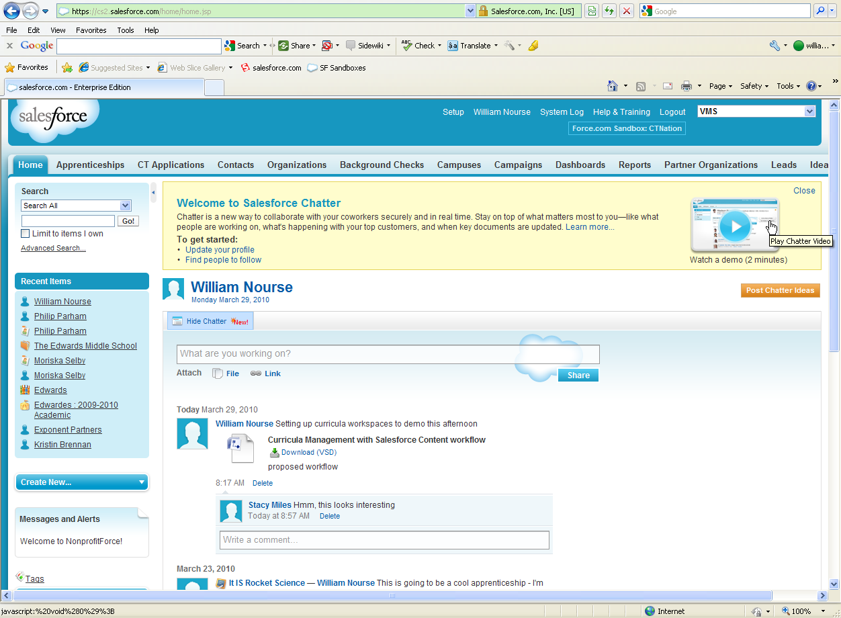

To write an update, type text in the field that says ‘What are you working on’ and click the Share button. If you want to attach a file or a link, click the appropriate link before you click the Share button. If you’ve posted an update that you want to retract, click the Delete button under the update.

A User Feed Item will display only the User’s name, which if clicked, will take you to their profile. A Record Feed Item will display the icon for the object type, the Record Name and then the User’s Name who made the post or made the update. Clicking on the Record Name link will take you to the specific record.

In addition, any object type (e.g. Contact, Organization, Campus, or Apprenticeship) which has been enabled for Chatter will also display its News Feed at the top of the page as well as its Follow or Unfollow icon. From the record page, you can make a Feed Post or comment on a prior post.

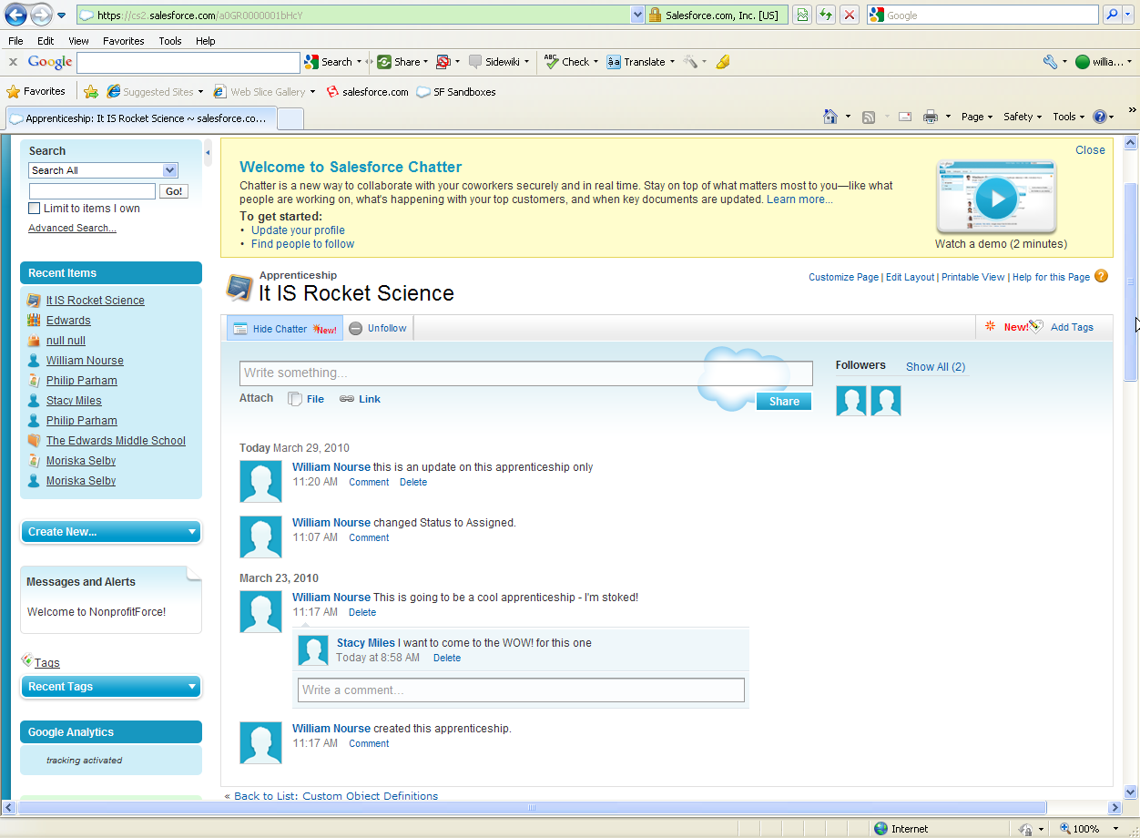

You can also post a file or link to a record’s Feed, which is a great way to associate content that is associated with it in a way that would be easily discoverable.

The right hand side of the page will show icons for each user who is following the record. If the user has uploaded a picture to their profile, the picture will be displayed here.

### The Chatter Application

Chatter adds two new tabs to the Salesforce system. Rather than adding those tabs onto your existing Applications (most of which already have too many tabs), there is a Salesforce Chatter application that can be accessed by clicking in the drop-down box in the upper right corner of the window.

Selecting this option allows the user to select the User Profile tab or the People tab.

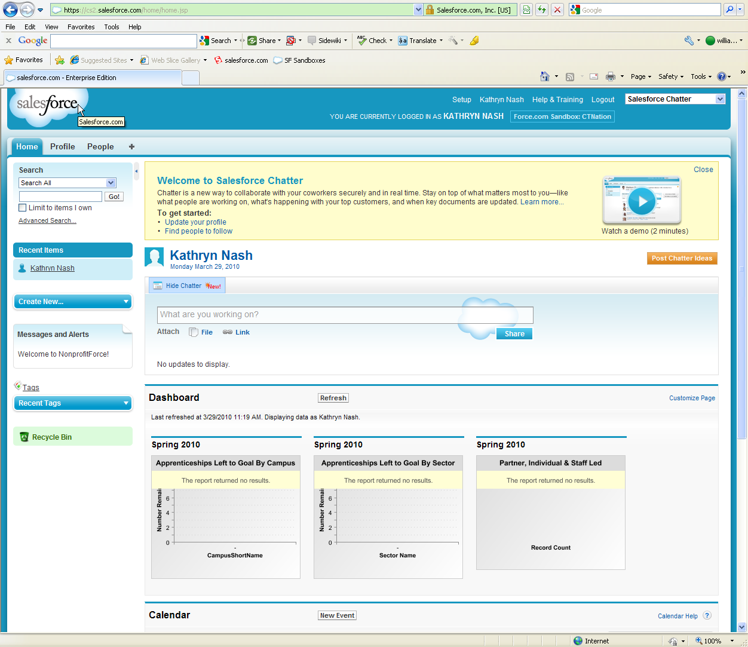

### User Profile:

Clicking on the Profile tab will display the logged-in user’s profile. In addition,every page in Salesforce will now have a link at the top next to the Setup link with your Name (or the logged in user’s name).

The User Profile page displays the Feed Items that you’ve posted, who’s following you and who (and what) you’re following. You can update sections of your profile by clicking on the Pencil icons next to the Contact and About Me sections on the left side of the page.

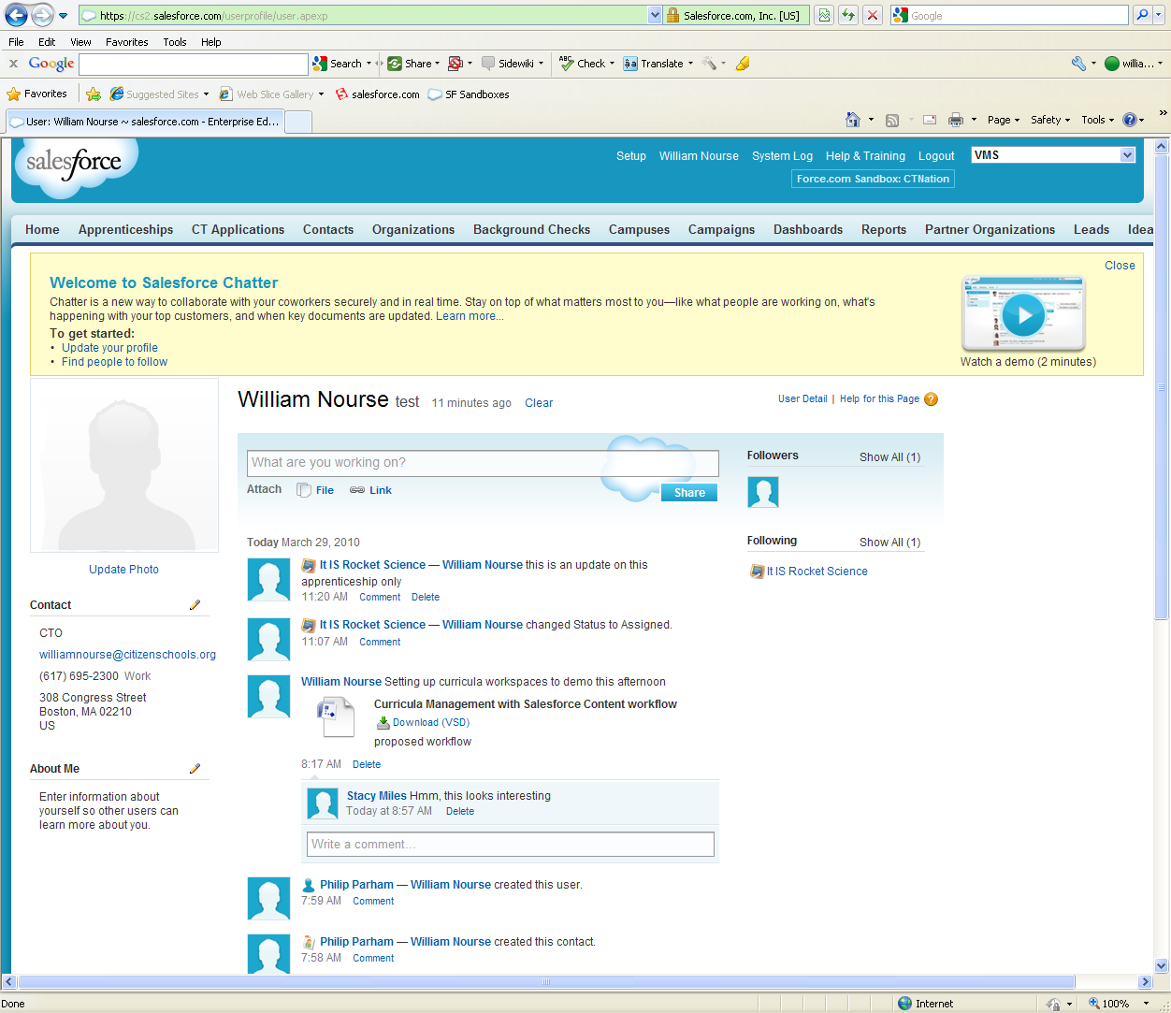

### The People Tab

This tab provides a search mechanism for other users within Salesforce so that you can choose to follow or unfollow people quickly. Given the relatively small number of named users we have, this isn’t a huge benefit to our organization right now, but as our numbers increase, it will become increasingly useful.

Viewing the list of users available, you can either click on the Green ‘Follow’ icon next to their name, or if you want to view their details, click on the link in the Full Name column. This will display that User’s Profile page, along with the Feed Items that they’ve posted and the list of who they’re following and who’s following them.

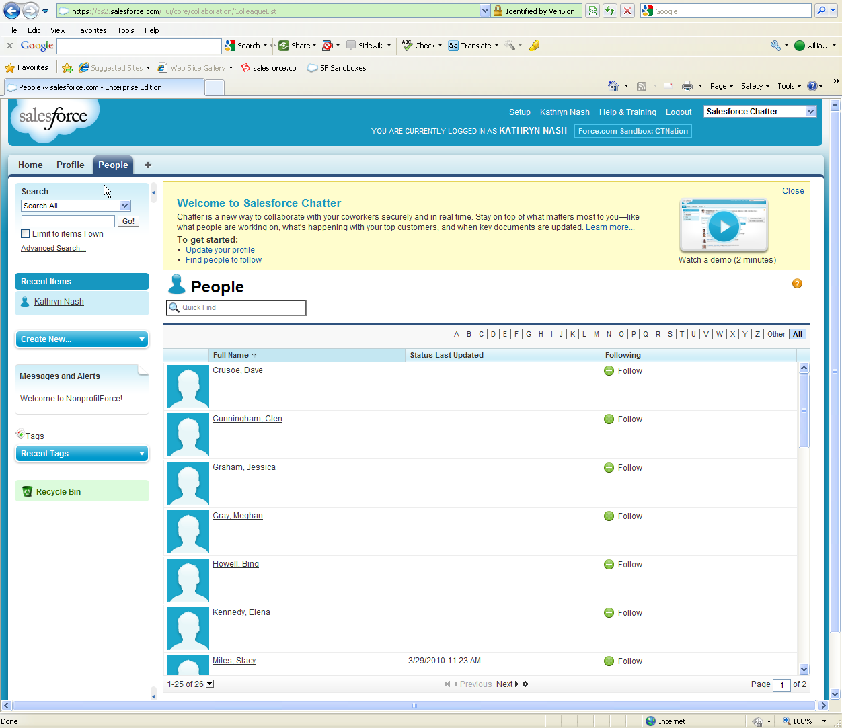

### Personal Chatter Settings

To update your personal settings around Chatter Email notifications, click on the Setup link at the top of the page and expand the My Chatter Settings section, then click on the My Chatter Emails link to set your email settings.

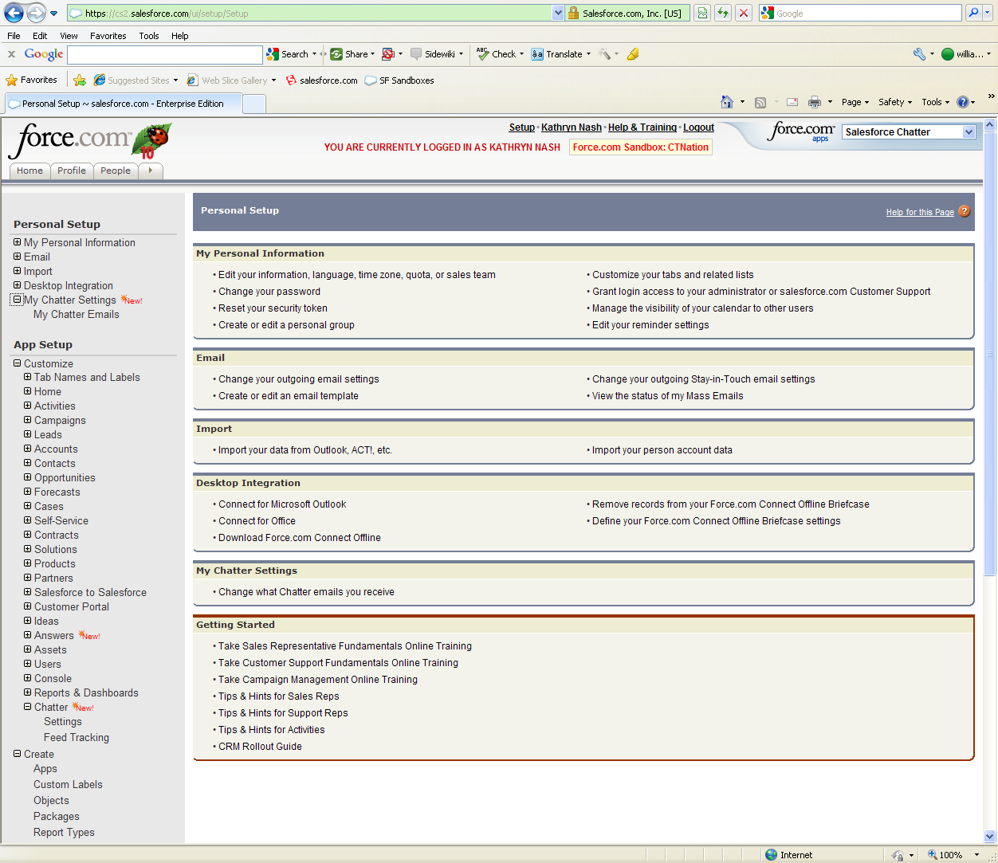

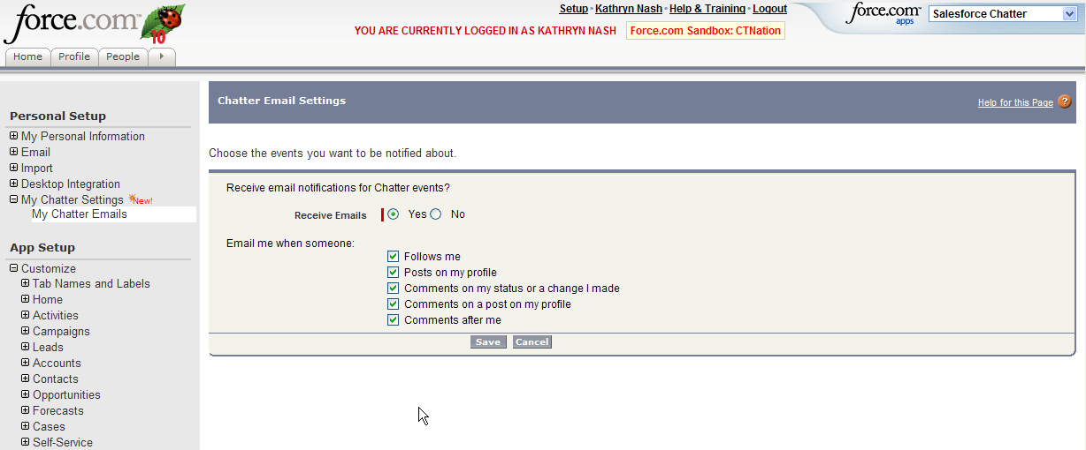

Here you can choose to receive emails or not, and if yes, choose which types of notifications you would like to receive.

### Checklist for Using Salesforce Chatter

1. Log in to Salesforce
2. Change your Application to Salesforce Chatter
3. Click on your Profile tab and update your profile
4. Click on the People tab and find people to Follow. Then click on the green’ Follow ‘ icon to subscribe to their updates.
5. Change your Application back to what your regularly use (e.g. VMS, Program Database).
6. Find some records that you are working with and click on the Follow icon once you’re in the individual record.
7. Start communicating with your colleagues using Chatter!